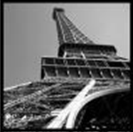P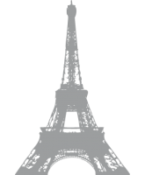ris
I’m bad when I think of Paris…
If only, if only… I wish I could go back to Paris
I’d like to see again this fabulous tower
If only, if only… I wish I could go back to Paris

I wish I could eat delicious pancakes once again
If only, if only… I wish I could go back to Paris
I’d like to feel again the rain from there
If only, if only… I wish I could go back to Paris
I would look at children enjoying themselves in this park
If only, if only… I wish I could go back to Paris
Paris is the most wonderful city in the world!
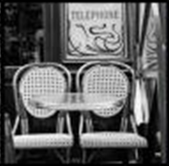
RAMDANE Sabrine
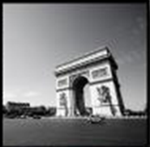RODRIGUEZ Maeliss

